**Week-2**

Task-2

**Name :- R.Gayathri**

**EMP id:- 11434**

**Domain :- python**

Set with in built functions :-

* Difference()
* Difference update()
* Discard()
* Intersection()
* Intersection update()
* Isdisjoint()
* Issubset()
* Issuperset()
* Symmetric difference()
* Symmetric difference update()
* Union()

Difference():-

Returns a set containing the difference between two or more sets.

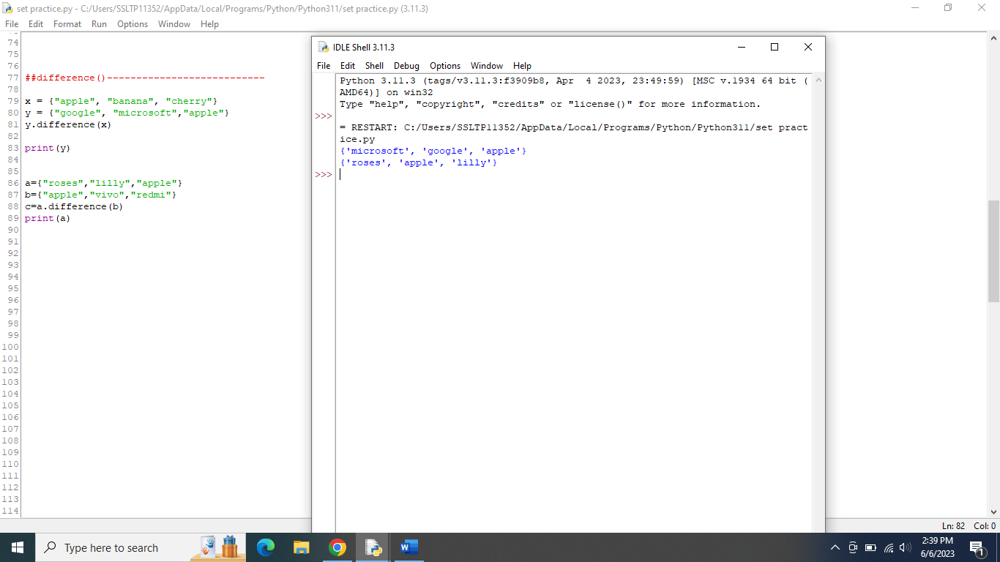

Difference update():-

Removes the items in this set that are also included in another, specified set.

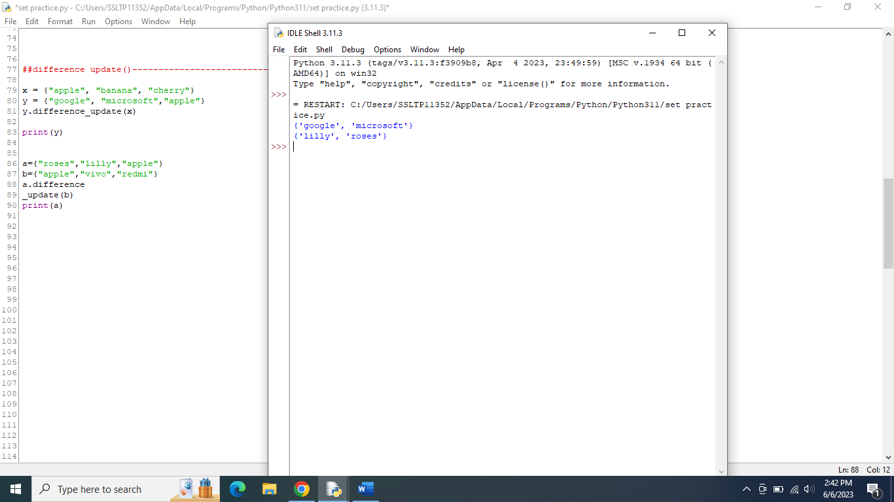

Discard():-

Remove the specified item.

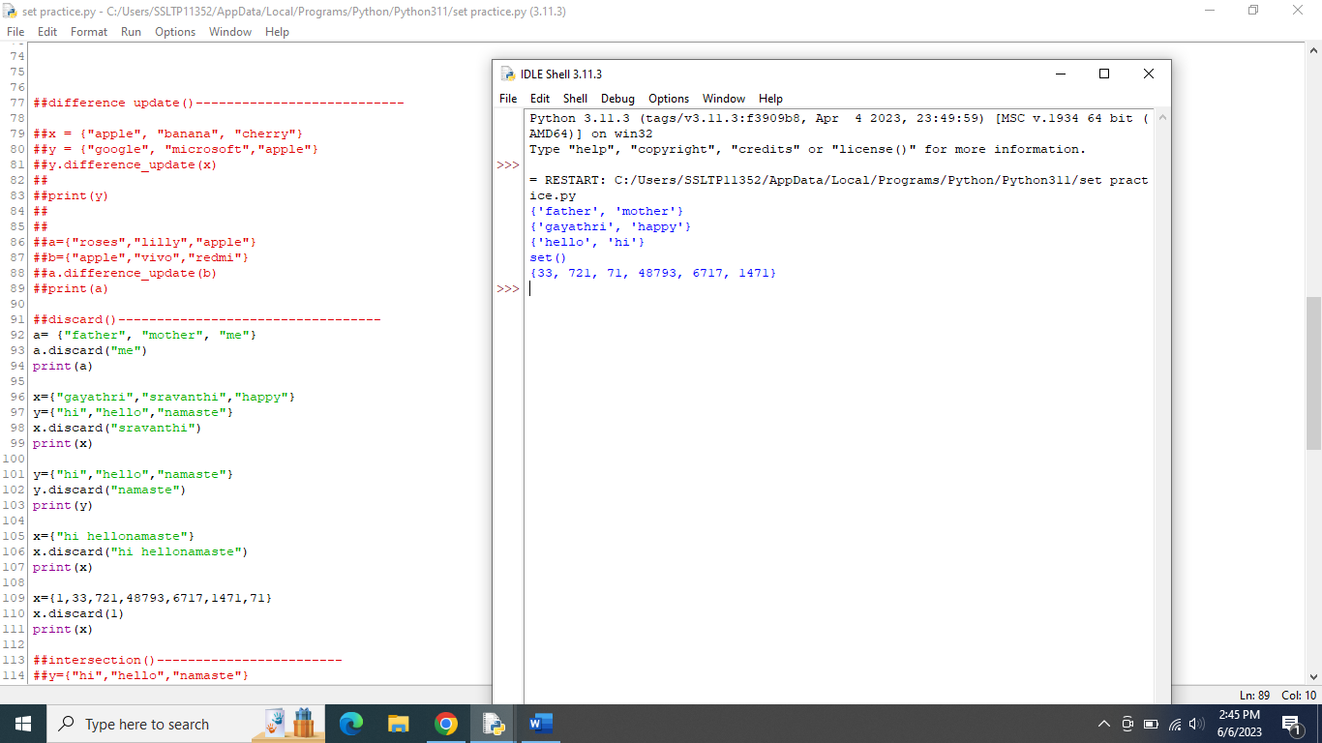

Intersection():-

Returns a set, that is the intersection of two or more sets.

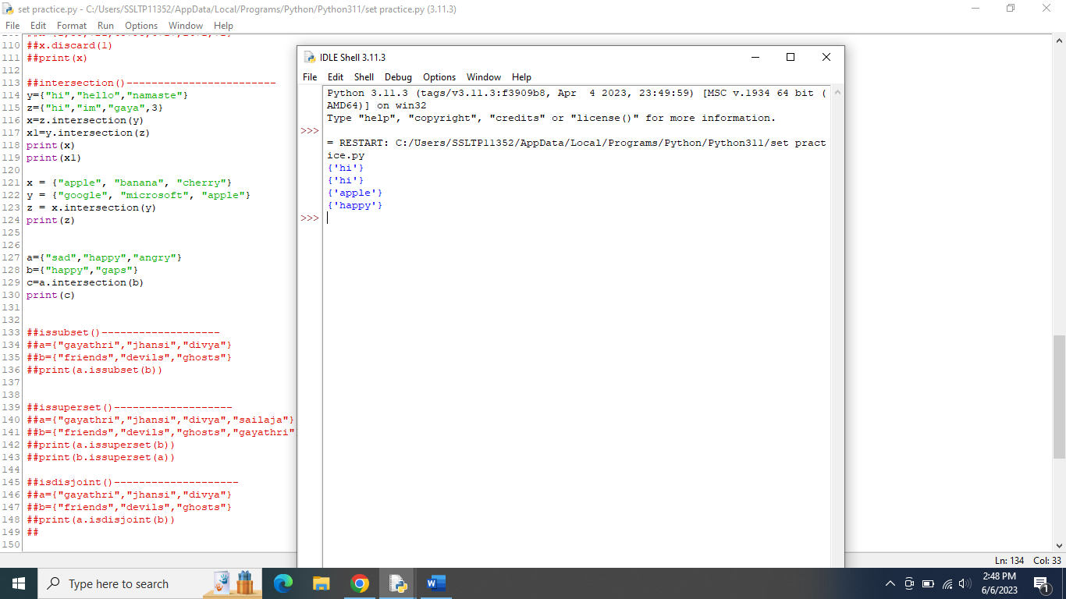

Intersection update():-

Removes the items in this set that are not present in other, specified set(s).

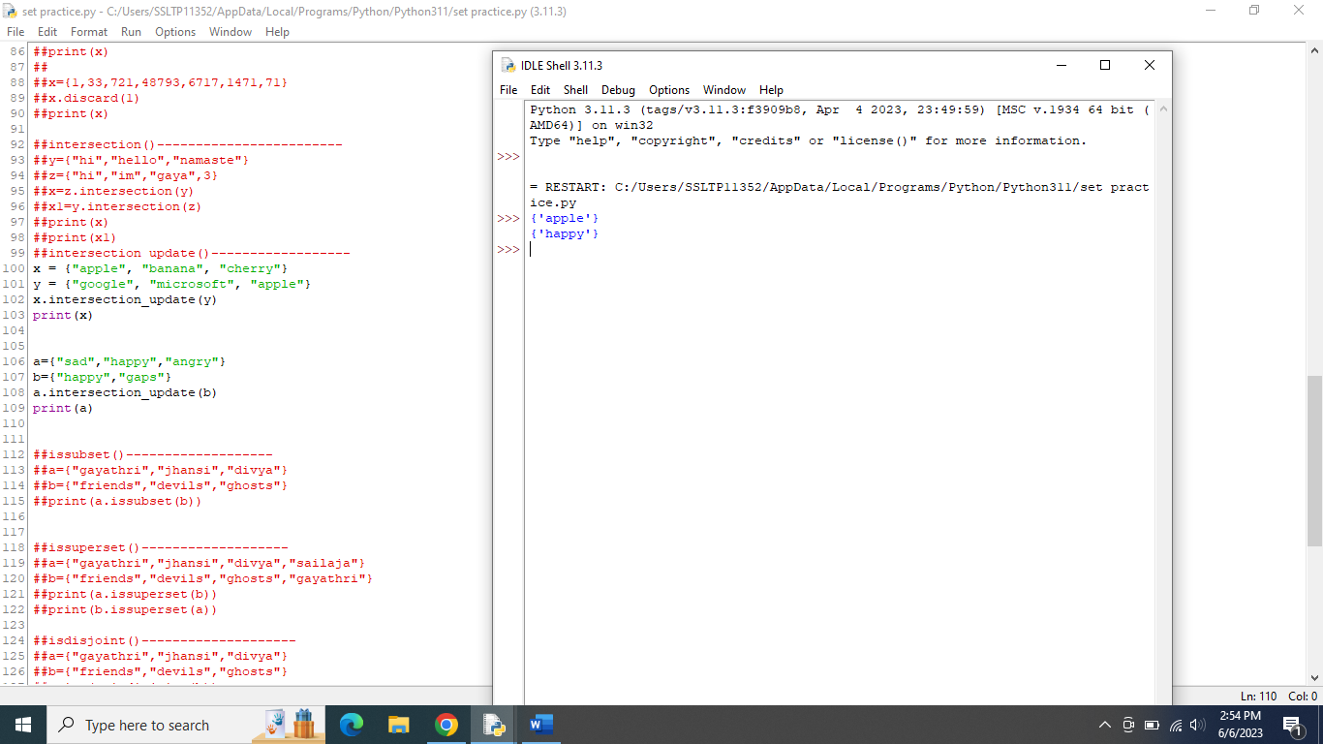

Isdisjoint():-

Returns whether two sets have a intersection or not.

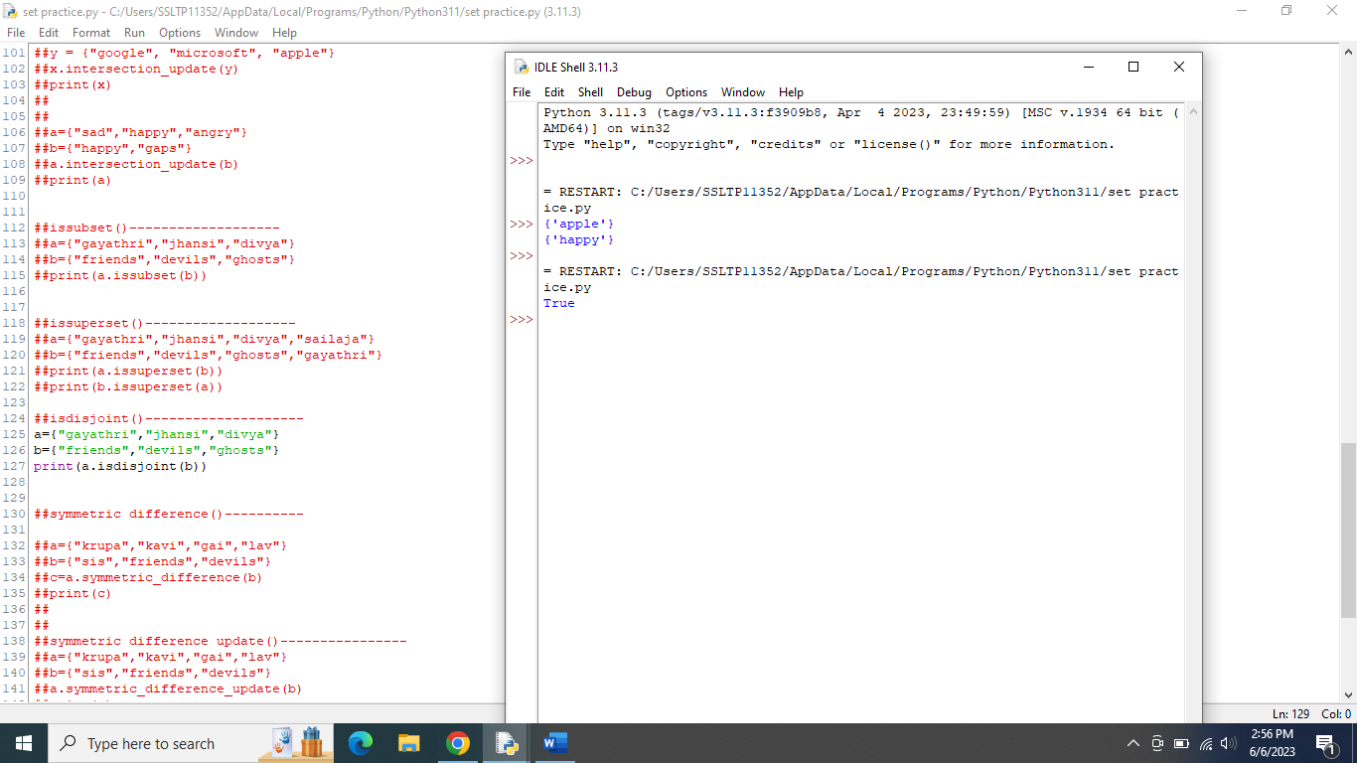

Issubset():-

Returns whether another set contains this set or not.

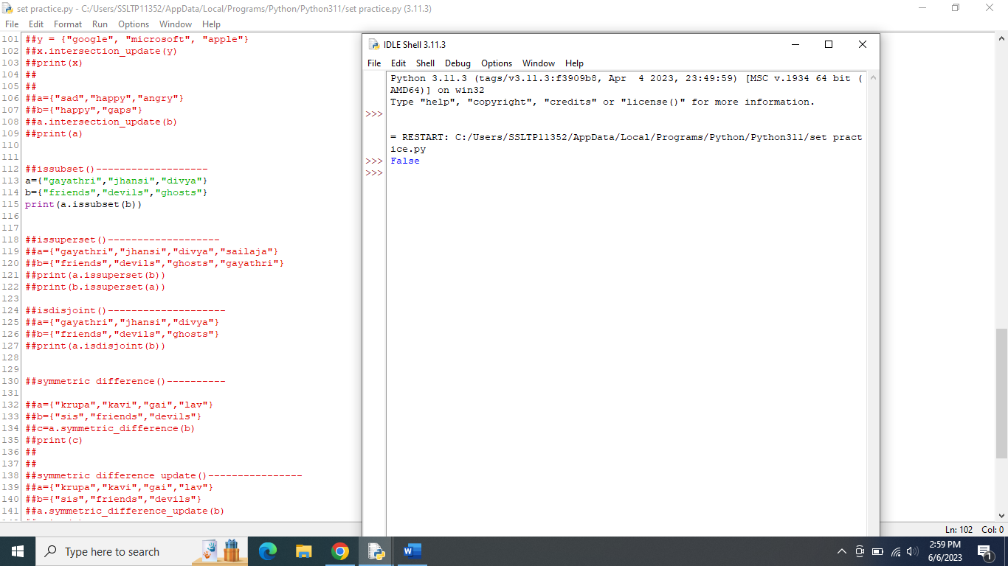

Issuperset():-

Returns whether this set contains another set or not.

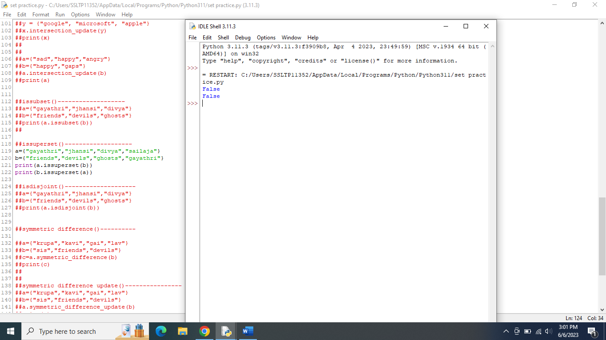

Symmetric difference():-

Returns a set with the symmetric differences of two sets.

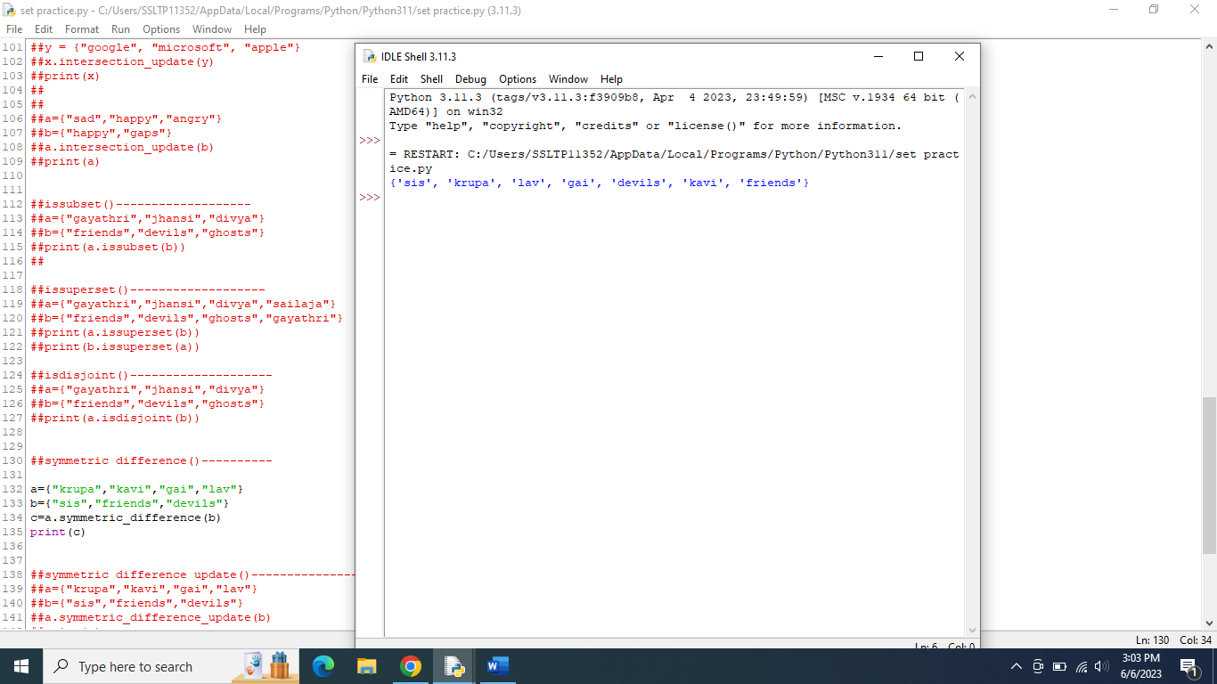

Symmetric difference update():-

inserts the symmetric differences from this set and another.

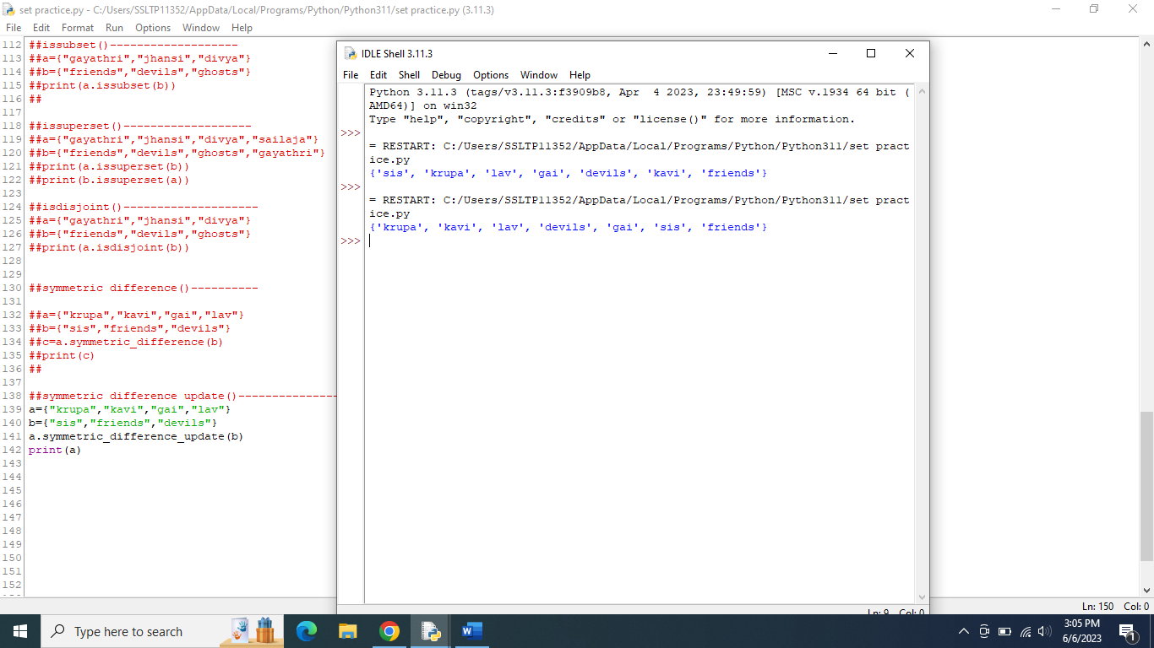

Union():-

Return a set containing the union of sets.

